**Universidad De las Fuerzas Armadas ESPE**

**OOP**

**Homework 02 Project Definition**

**TEAM 1: A-Byte Wizards**

1. **FRANK ALVARADO GREFA**

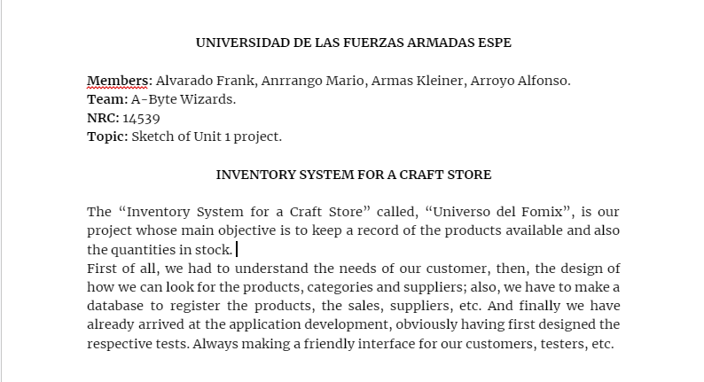

1. **MARIO SANTIAGO ANRRANGO BENAVIDES**



1. **KLEINER ALEXIS ARMAS GOMEZ**



1. **ALFONSO ALEJANDRO ARROYO PAREDES**



**Team 2: Overnight Developers Squad**

1. **JULIO CESAR BLACIO MACHUCA**
2. **MIGUEL ANGEL CAIZA OÑA**
3. **KERLLY ALEXANDRA CHIRIBOGA CABRERA**
4. **JOFFRE ESTEBAN GÓMEZ QUINALUISA**

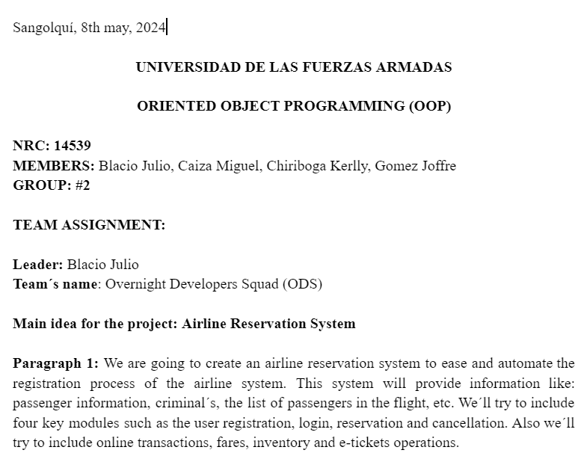

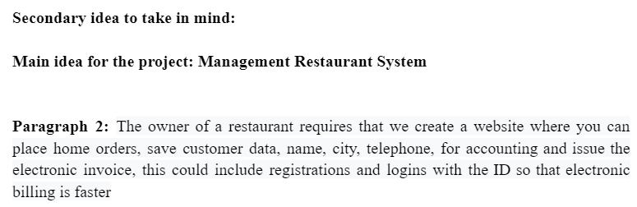

1. **RICARDO ANDRES LAINEZ SUAREZ**
2. **JERSON STIVEN LLUMIQUINGA MORENO**
3. **ZAITH ALEJANDRO MANANGON VINUEZA**
4. **HEIDY SOLANGE MERA ROSERO**

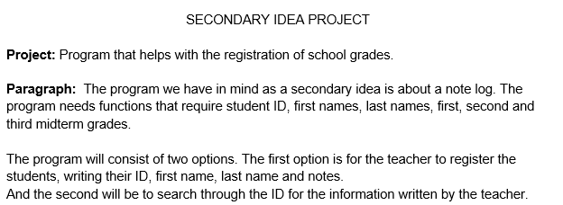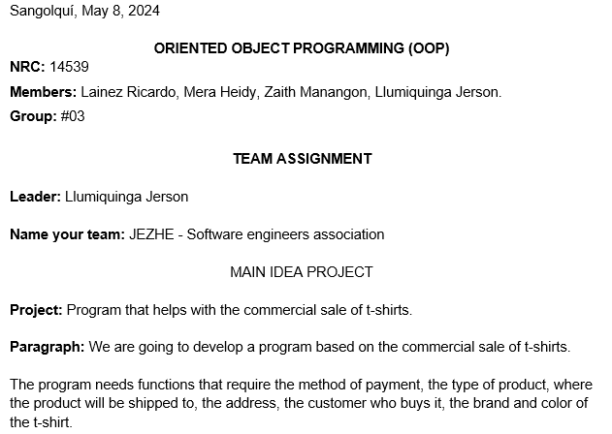

**Team 4 [ CodeCrafting Engineers]**

1. **GABRIEL ANTHONY MOLINA GALLEGOS**
2. **LEYDI ESPERANZA OÑA SUQUILLO**
3. **MARCO ADRIAN PADILLA TRIVIÑO**
4. **DAVID ALEXANDER PILAGUANO CHISAGUANO**

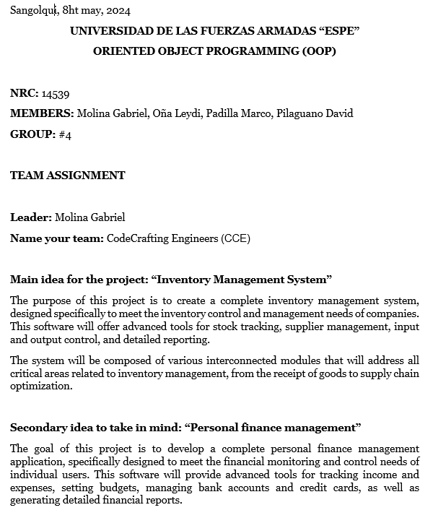

**TEAM 5 [Paradigm Pioneers Squad]**

1. **ANDREA KATHERINE RAURA NEGRETE**
2. **JEANCARLO JAVIER SANTI CRUZ**
3. **LEIDY LISBETH SARAGURO CHAVEZ**
4. **KENNED JHAIR SIGCHA PALMA**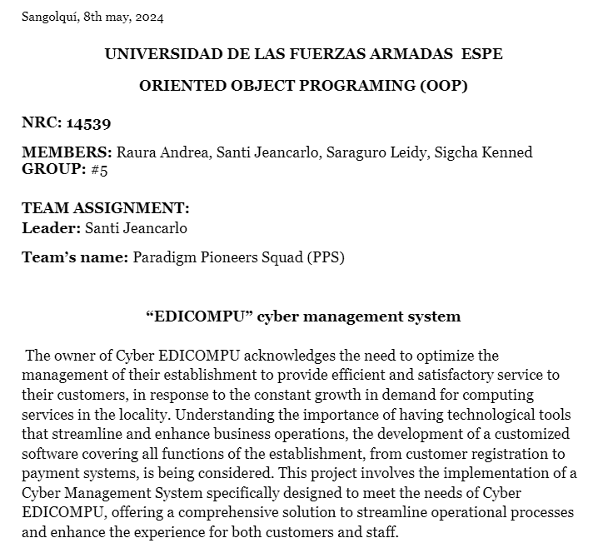
5. **YOSTIN ARIEL SISALEMA JIMENEZ**
6. **EDGAR DAMIAN TOSCANO CORO**

**22. ERICK ALEJANDRO TUFIÑO ORTIZ**

